**Commodore VIC-20: Hyper Expander Rev. 0**

**Testing**

# Test Setup

The tests were conducted with a VIC-20 (ASSY 250403 Rev. D) and a Hyper Expander cartridge (Rev. 0) with a HN61256BLP-7 RAM and up to two 27C512 EPROMs.

# Test Execution

## Super Expander Software

First, the original Super Expander Software from zimmers.net and the VIC-MON for $B000 were programed to an EPROM. These two programs fit into one 8k memory bank, since the Super Expander software is a 4k software. The EPROM was inserted the in IC1 socket and (JP1) was set to ($A000-$BFFF). The RAM was configured to 3k RAM expansion only (JP4=3k, J5: 7-8 only = BLK5/3k).

The cartridge was inserted into the VIC-20 and the computer was switched on. It booted normally and 6519 Bytes Free were reported. The Super Expander requires bytes in RAM, so this is correct.

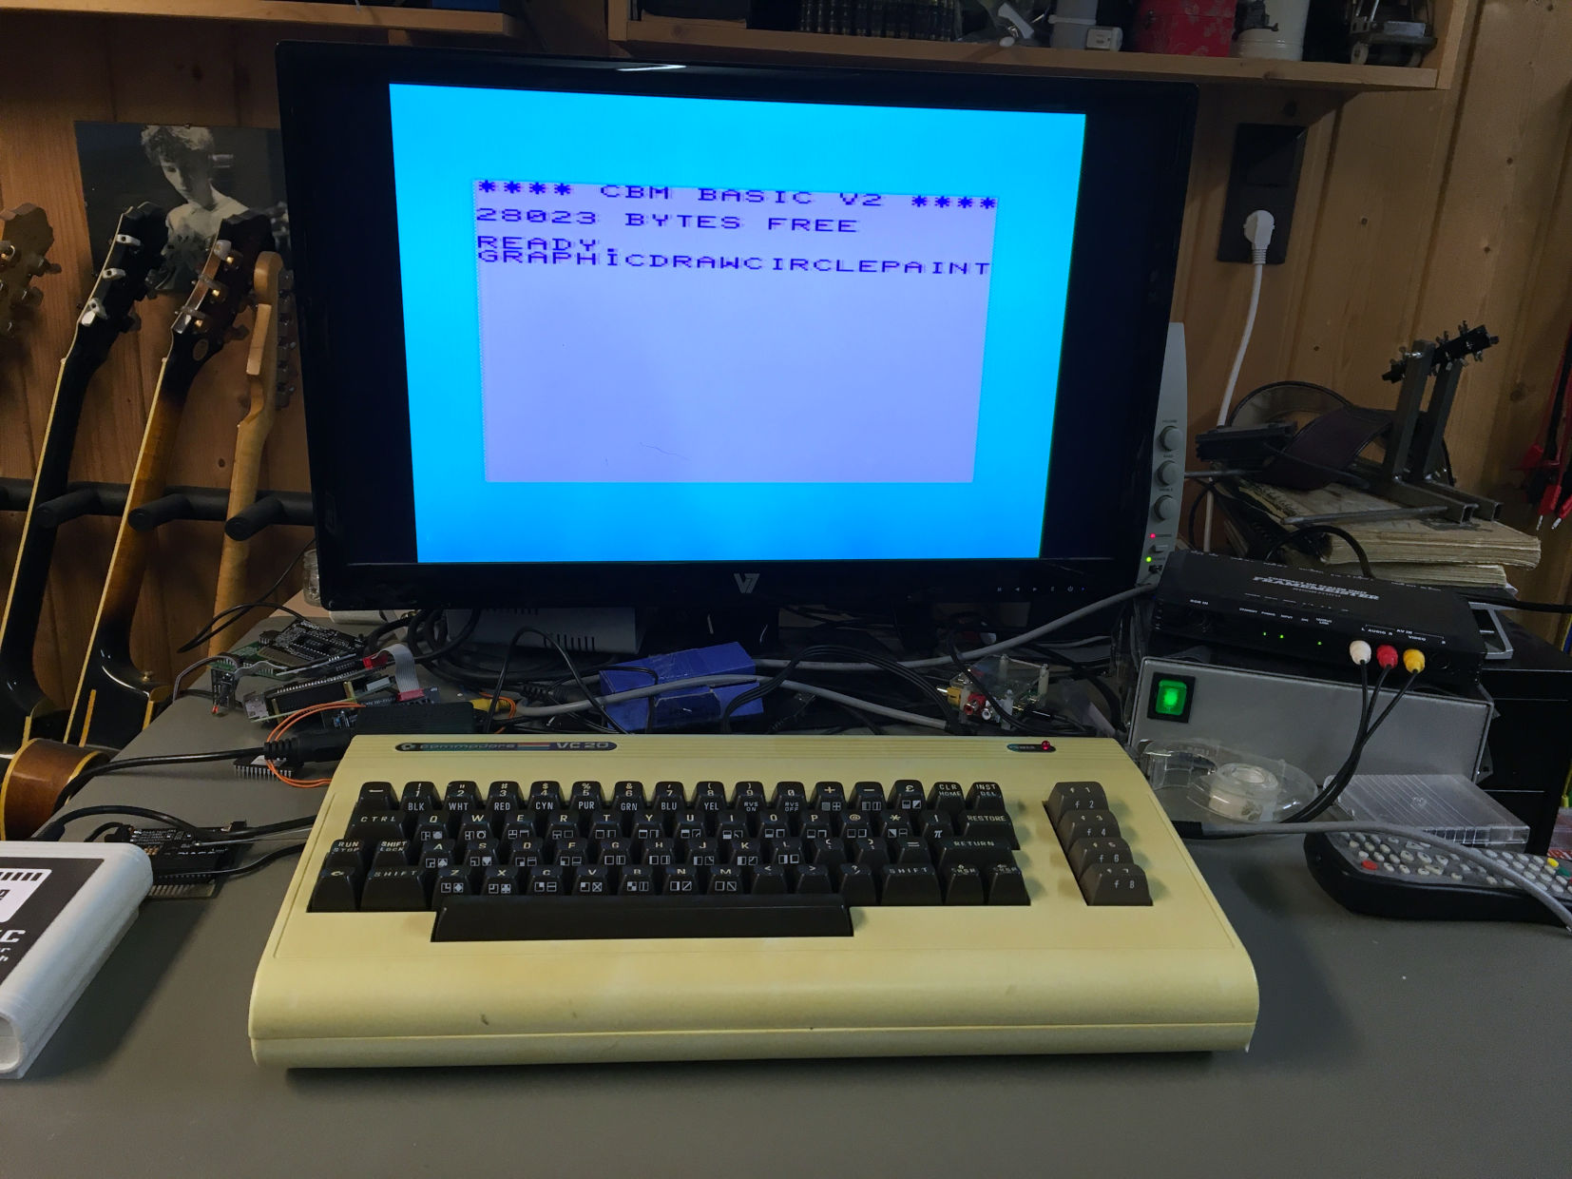

Figure 1: Test with Super Expander Firmware and full RAM expansion

The function keys produce some of the additional Super Expander instructions. A short program, which is using those instructions, was executed successfully.

* **Function of RAM and EPROM IC1 with and the Super Expander Software verified.**

SYS11*4096 (which is $B000) started the VIC-MON.

* **Additional test.**

The Super Expander Software was tested with all other RAM configurations, the VIC-20 always booted properly.

## RESET Button

The RESET button (SW1) was pressed. The VIC-20 rebooted properly.

* **RESET button verified**

## VIC-20 Diagnostic Software

The software (PAL) also origins from zimmers.net. It was programmed into the 2nd 8k of the said EPROM, a different version of this software (NTSC) was programmed to the 3rd 8k.

The jumpers on JP3 were set to the 2nd 8k (A15...A13: set open), JP1 remained at .

The RAM was configured to 3k Expansion only.

The diagnostics software started and executed properly (together with the VIC-20 diagnostics harness). For the 2nd version of the diagnostic software, JP3 was set to the 3rd 8k bank (A15...A13: set open set). This software executed properly, too.

* **Bank select (000, 001, 010) on JP3 verified**

## Game Cartridge Donkey Kong

This game is a 16k game and requires both EPROMs.  
The software for $A000 was programmed in a fresh EPROM, which was inserted into IC1. JP1 remained at . The other part of the software, which is located at $2000 was programmed into another fresh EPROM, which was then inserted into the IC2 socket. JP2 was set to . All jumpers on JP3 were set.

The software started properly and the game could be played.

* **EPROM IC2 with verified**

## Game Cartridge AE

The software origins from zimmers.net. It consisted of two images, one for $A000 and one for $6000. The images were programmed into two EPROMs, the $A000 software was inserted into IC1, the $6000 software into IC2. Jumper JP1 was set to , JP2 to . The software started properly and the game could be played.

* **EPROM IC2 with verified**

## VIC-MON (for $4000)

The source of this software is once again zimmers.net. It was programmed into the 5th 8k memory bank (@ buffer address $8000) of an EPROM. The EPROM was inserted into IC1 and JP1 was set to .

SYS4x1022 started the software properly.

* **Bank select (100) on JP3 and (JP1) verified**

## RAM Test

The RAM configuration was tested with the RAM Expansion Test Software Rev. 0.0 (<https://github.com/svenpetersen1965/VIC-20-RAM-Expansion-Test-Software>)

This software tests every bit in a RAM block for LOW and for HIGH. Also address line conflicts and a cross talk to other RAM blocks are detected.

In the first pass, the RAM Test was running from the on-board EPROM IC1, configured to $A000 with BLK5). The 4th RAM block was configured to be the 3kByte RAM expansion.

The test was running several thousand times without reporting any problems.

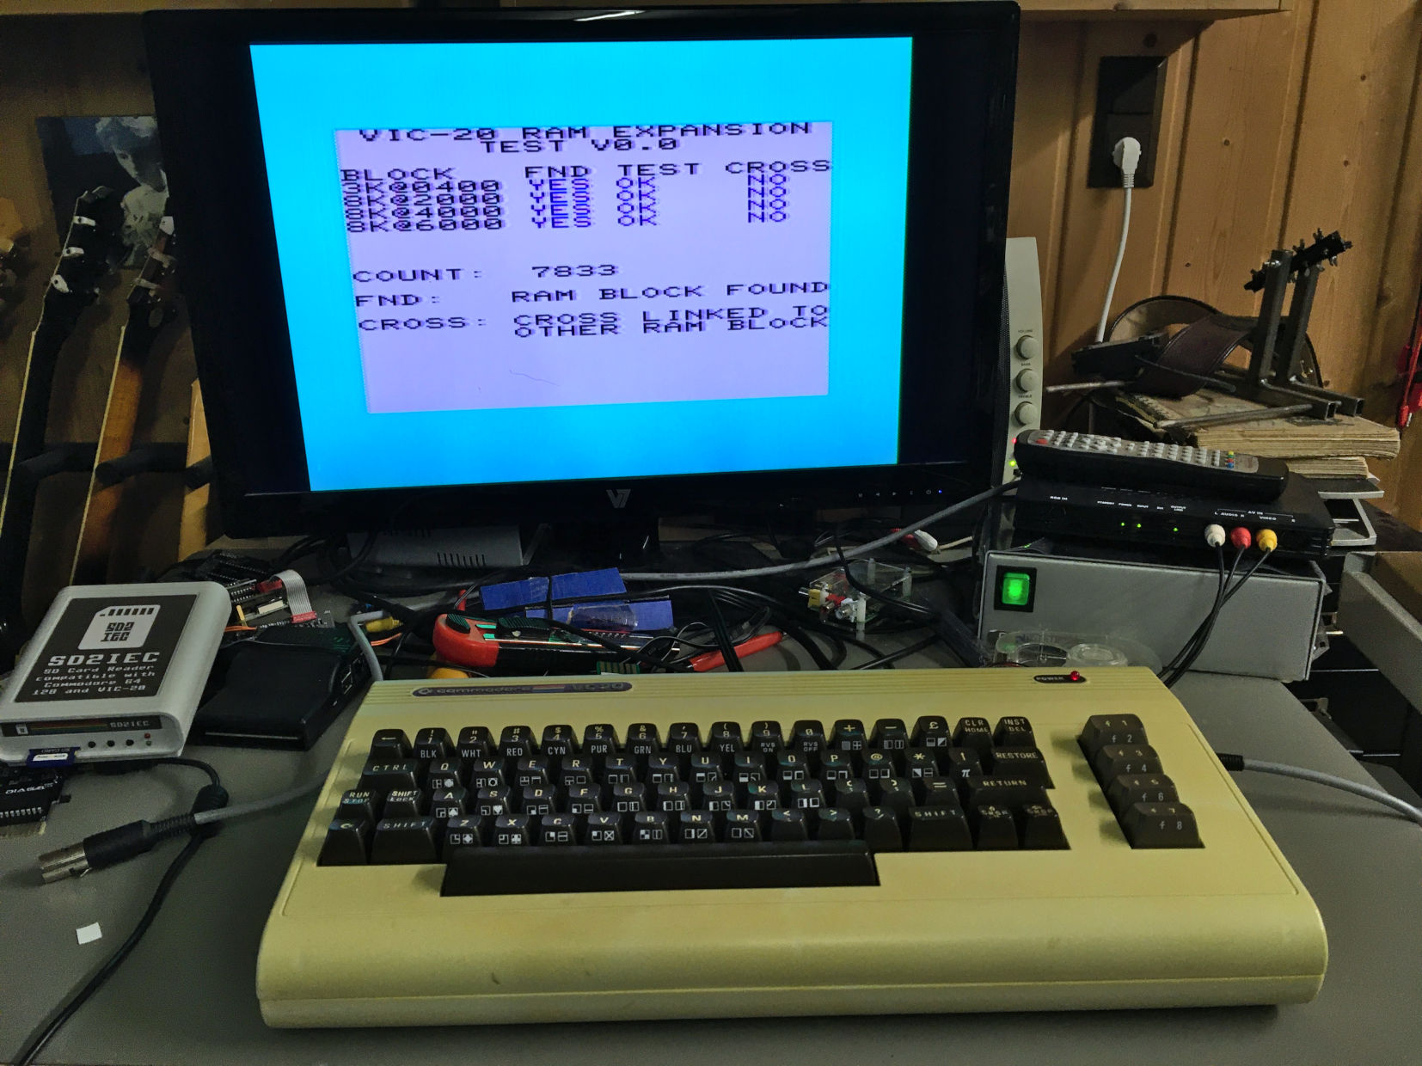

Figure 2: RAM Expansion Test running from EPROM

To test the 4th RAM bank configured at $A000, the EPROM was removed and the JP4 was set to BLK5.

This test configuration did not report any problems, either.

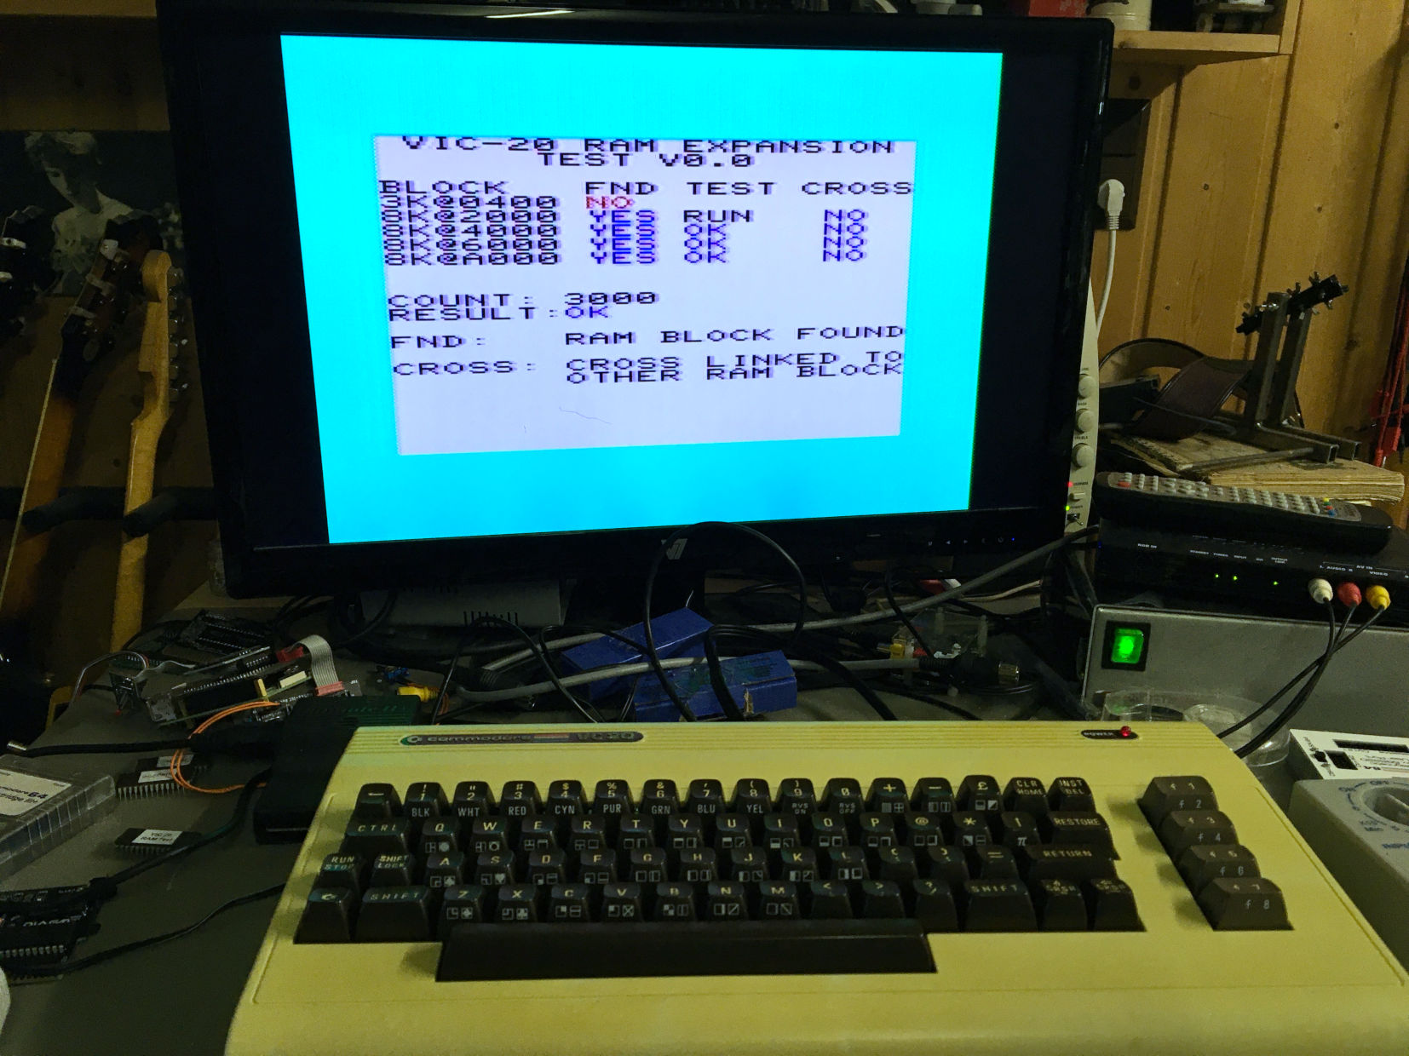

Figure 3: RAM Expansion Test running from a disk image

* **RAM function verified**

## Installation in cartridge cases

The fully assembled Hyper Expander PCB (all ICs on sockets and all vertical jumpers) was installed in the **original Commodore Super Expander cartridge case**. This could be accomplished without a problem.

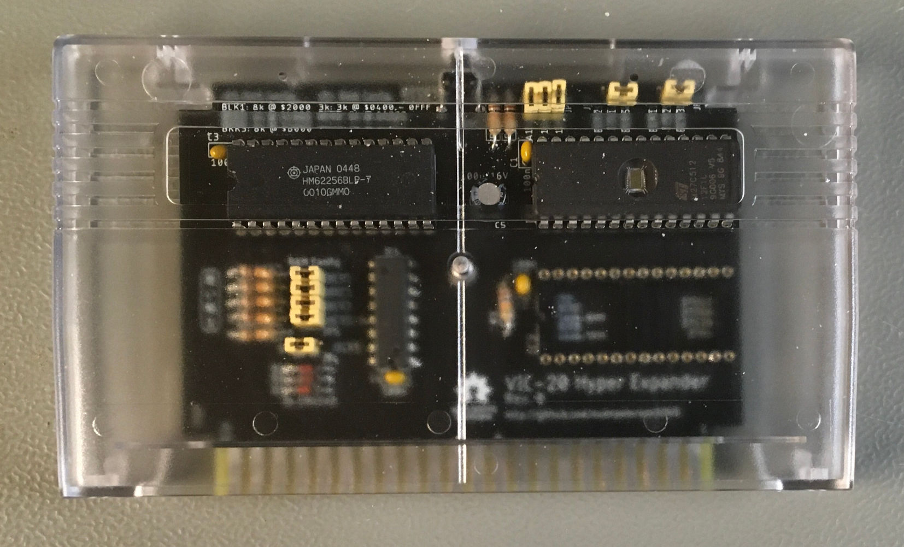

Figure 4: Installation in a tfw8bit case

The **original Commodore Game cartridge case** required removing some support structures for small PCBs, after that, it also fit.

The **tfw8bit.com VIC-20 cartridge case** fits after removing the support structures for the short PCBs.

In case the RESET switch is desired, the cases require a modification (5mm hole in the back)

* **Dimensions verified**

# Conclusion

**The Hyper Expander Rev. 0 is fully functional**